# Quadrature Phase Shit Keying

## Common

Consider the following **unit energy ( $E_{p1}=1$ and $E_{p2}=1$)** pulses,

$$P_{1}\left(t\right)=\sqrt{\frac{2}{T}}\cos{(2πf_{c}t)}$$

$$P_{2}\left(t\right)=\sqrt{\frac{2}{T}}\sin{(2πf_{c}t)}$$

Where, $0≤t≤T, T=k/{f_{c}},k ϵ{ z}^{+}$, $T$ can be identified as an integer number of cycles

$$P_{1}\left(t\right)=\sqrt{\frac{2}{T}}\cos{(2πf_{c}t)}=\sqrt{\frac{2}{T}}\sin\left(2πf_{c}t+π/2\right)$$

$$P_{2}\left(t\right)=\sqrt{\frac{2}{T}}\sin{(2πf_{c}t)}=\sqrt{\frac{2}{T}}\cos\left(2πf_{c}t-π/2\right)$$

Observing that $P_{1}\left(t\right)$ is a phase shifted version of $P_{2}\left(t\right)$ and $P_{2}\left(t\right)$ is a phase shifted version of $P_{1}\left(t\right)$

Showing the unit energy of $P_{1}\left(t\right)$ and $P_{2}\left(t\right)$

$$E_{p1}=\int_{-∞}^{∞}{P_{1}^{2}\left(t\right)dt}=\int_{0}^{T}{\left(\frac{2}{T}\right)\cos^{2}\left(2πf_{c}t\right) dt}=1$$

$$E_{p2}=\int_{-∞}^{∞}{P_{2}^{2}\left(t\right)dt}=\int_{0}^{T}{\left(\frac{2}{T}\right)\sin^{2}\left(2πf_{c}t\right) dt}=1$$

Calculating the inner-product between the $P_{1}\left(t\right)$ and $P_{2}\left(t\right)$

$$〈P_{1}\left(t\right),P_{2}\left(t\right)〉=\int_{-∞}^{∞}{P_{1}\left(t\right). P_{2}\left(t\right) dt}=\int_{-∞}^{∞}{\sqrt{\frac{2}{T}}\cos{(2πf_{c}t)}. \sqrt{\frac{2}{T}}\sin{(2πf_{c}t)} dt}$$

$$= \frac{2}{T}\int_{-∞}^{∞}{\cos{(2πf_{c}t)}. \sin{(2πf_{c}t)} dt}=\frac{1}{T}\int_{-∞}^{∞}{ \sin{(4πf_{c}t)} dt}=0$$

Hence, $P_{1}\left(t\right)$ and $P_{2}\left(t\right)$ are orthogonal unit energy pulses. It forms the orthonormal basis of signal space $x(t)$

## Modulation

Consider two bits of information $x(t)$,

$$x\left(t\right)=a_{1}P_{1}\left(t\right)+a_{2}P_{2}\left(t\right)$$

Two symbols $a_{1}$ and $a_{2}$ are be modulated with $P_{1}\left(t\right)$ and $P_{2}\left(t\right)$. Each pulse can carry a single bit of information.

**E.g :- $a_{1}=±A , a_{2}=±A$** , the average bit energy $E_{b}=A^{2}$

Set of 4 possible signals form the sample space in QPSK with the orthonormal basis functions of $P_{1}\left(t\right)$ and $P_{2}\left(t\right)$.

$$x(t)\left\{\begin{aligned}{x_{1}\left(t\right)=+A{.P}_{1}\left(t\right)+A{.P}_{2}\left(t\right) \atop x_{2}\left(t\right)=+A{.P}_{1}\left(t\right)-A{.P}_{2}\left(t\right)} \\ {x_{3}\left(t\right)=-A{.P}_{1}\left(t\right)+A{.P}_{2}\left(t\right) \atop x_{4}\left(t\right)=-A{.P}_{1}\left(t\right)-A{.P}_{2}\left(t\right)}\end{aligned}\right.$$

Waveforms of QPSK modulated signals,

Considering particular waveforms in signal space,

$x_{1}\left(t\right)$:

$$x_{1}\left(t\right)=A{.P}_{1}\left(t\right)+A{.P}_{2}\left(t\right)=A.\sqrt{\frac{2}{T}}\cos{(2πf_{c}t)}+A.\sqrt{\frac{2}{T}}\sin{(2πf_{c}t)}$$

$$=\frac{2A}{\sqrt{T}}\left\{\frac{1}{\sqrt{2}}\cos{(2πf_{c}t)}+\frac{1}{\sqrt{2}}\sin{(2πf_{c}t)}\right\}=\frac{2A}{\sqrt{T}}\cos\left(2πf_{c}t-π/4\right)$$

$x_{2}\left(t\right)$:

$$x_{2}\left(t\right)=A{.P}_{1}\left(t\right)-A{.P}_{2}\left(t\right)=A.\sqrt{\frac{2}{T}}\cos\left(2πf_{c}t\right)-A.\sqrt{\frac{2}{T}}\sin{(2πf_{c}t)}$$

$$=\frac{2A}{\sqrt{T}}\left\{\frac{1}{\sqrt{2}}\cos{(2πf_{c}t)}-\frac{1}{\sqrt{2}}\sin{(2πf_{c}t)}\right\}=\frac{2A}{\sqrt{T}}\cos\left(2πf_{c}t+π/4\right)$$

$x_{3}\left(t\right)$:

$$x_{3}\left(t\right)=-A{.P}_{1}\left(t\right)+A{.P}_{2}\left(t\right)=-A.\sqrt{\frac{2}{T}}\cos{(2πf_{c}t)}+A.\sqrt{\frac{2}{T}}\sin{(2πf_{c}t)}$$

$$=\frac{2A}{\sqrt{T}}\left\{-\frac{1}{\sqrt{2}}\cos{(2πf_{c}t)}+\frac{1}{\sqrt{2}}\sin{(2πf_{c}t)}\right\}=\frac{2A}{\sqrt{T}}\cos\left(2πf_{c}t+{5π}/4\right)$$

$x_{4}\left(t\right)$:

$$x_{4}\left(t\right)=-A{.P}_{1}\left(t\right)-A{.P}_{2}\left(t\right)=-A.\sqrt{\frac{2}{T}}\cos\left(2πf_{c}t\right)-A.\sqrt{\frac{2}{T}}\sin{(2πf_{c}t)}$$

$$=\frac{2A}{\sqrt{T}}\left\{-\frac{1}{\sqrt{2}}\cos\left(2πf_{c}t\right)-\frac{1}{\sqrt{2}}\sin{(2πf_{c}t)}\right\}=\frac{2A}{\sqrt{T}}\cos\left(2πf_{c}t+{3π}/4\right)$$

$$x(t)\left\{\begin{aligned}{x_{1}\left(t\right)=\frac{2A}{\sqrt{T}}\cos\left(2πf_{c}t-π/4\right) \atop x_{2}\left(t\right)=\frac{2A}{\sqrt{T}}\cos\left(2πf_{c}t+π/4\right)} \\ {x_{3}\left(t\right)=\frac{2A}{\sqrt{T}}\cos\left(2πf_{c}t+{5π}/4\right) \atop x_{4}\left(t\right)=\frac{2A}{\sqrt{T}}\cos\left(2πf_{c}t+{3π}/4\right)}\end{aligned}\right.$$

Phase difference between successive waveforms is $π/2$, This implies the Quadrature phase shifting in this modulation scheme.

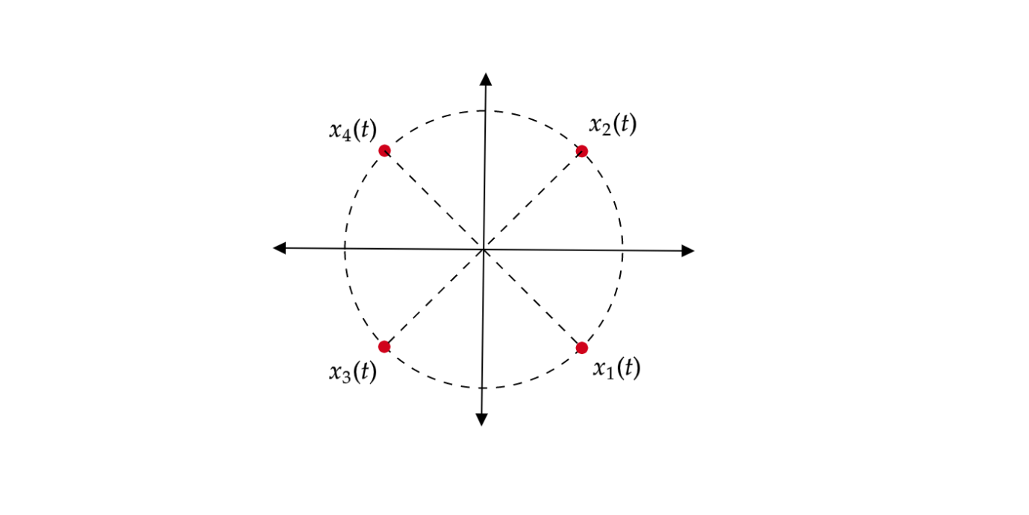

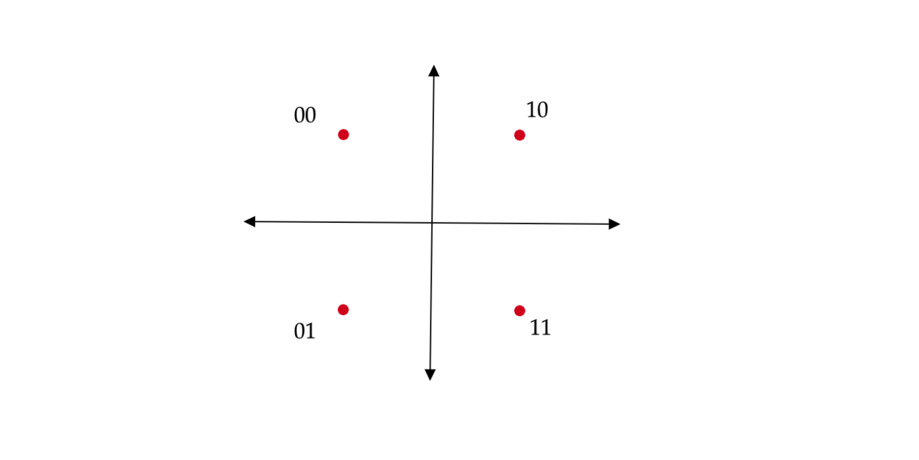

Figure 1: Constellation Diagram for QPSK

## Demodulation

**Logic:**

$x(t)$ is matched with $P_{1}\left(t\right)$ to recover $a_{1}$, and the $x(t)$ is matched with $P_{2}\left(t\right)$ to recover $a_{2}$

Required matched filter $h\left(t\right)=P(T-t)$,

Assume received signal as $y(t)$ and considering AWGN channel

$$y\left(t\right)=x\left(t\right)+n(t)$$

Where, $n\left(t\right)$ is white Gaussian noise with $E\left(n\right)=0$ and $R_{nn}\left(τ\right)=\frac{N_{0}}{2}δ(τ)$, $\frac{N_{0}}{2}$ is the power spectral density of the noise.

$$y\left(t\right)=a_{1}P_{1}\left(t\right)+a_{2}P_{2}\left(t\right)+n(t)$$

Applying matched filter $h_{1}\left(t\right)=P_{1}(T-t)$ to the received signal,

$$r_{1}\left(t\right)=y\left(t\right)*h_{1}\left(t\right)|_{t=T}$$

$$r_{1}\left(t\right)=\left[a_{1}P_{1}\left(t\right)+a_{2}P_{2}\left(t\right)+n(t)\right]*h_{1}\left(t\right)|_{t=T}$$

$$r_{1}\left(t\right)=\left[a_{1}P_{1}\left(t\right)+a_{2}P_{2}\left(t\right)\right]*h_{1}\left(t\right)|_{t=T}+n(t)*h_{1}\left(t\right)|_{t=T}$$

Considering signal component separately,

$$\left[a_{1}P_{1}\left(t\right)+a_{2}P_{2}\left(t\right)\right]*h_{1}\left(t\right)=\int_{-∞}^{∞}{\left[a_{1}P_{1}\left(t\right)+a_{2}P_{2}\left(t\right)\right]h_{1}\left(t-τ\right) dτ}$$

Substituting $h_{1}\left(t-τ\right)=P_{1}(T+τ-t)$,

$$\int_{-∞}^{∞}{\left[a_{1}P_{1}\left(t\right)+a_{2}P_{2}\left(t\right)\right]P_{1}(T+τ-t) dτ}$$

$$a_{1}\int_{-∞}^{∞}{P_{1}\left(τ\right)P_{1}(T+τ-t) dτ}+a_{2}\int_{-∞}^{∞}{P_{2}\left(τ\right)P_{1}(T+τ-t) dτ}$$

Sampling with period $T,$ $t=mT$, $m=1, 2, 3….$, then $P_{1}\left(T+τ-mT\right)= P_{1}\left[(1-m)T+τ\right]=P_{1}(τ)$, considering the periodicity property,

$$a_{1}\int_{-∞}^{∞}{P_{1}\left(τ\right)P_{1}(τ) dτ}+a_{2}\int_{-∞}^{∞}{P_{2}\left(τ\right)P_{1}(τ) dτ}$$

$$a_{1}\int_{-∞}^{∞}{P_{1}^{2}\left(t\right) dτ}+a_{2}\int_{-∞}^{∞}{P_{1}(τ) P_{2}\left(τ\right)dτ}$$

$$a_{1}×1+a_{2}×0=a_{1}$$

Considering the same analysis for matched filter $h_{2}\left(t\right)=P_{2}(T-t)$,and both results can be finalized as,

$$r_{1}\left(t\right)=a_{1}+\tilde{n}$$

$$r_{2}\left(t\right)=a_{2}+\tilde{n}$$